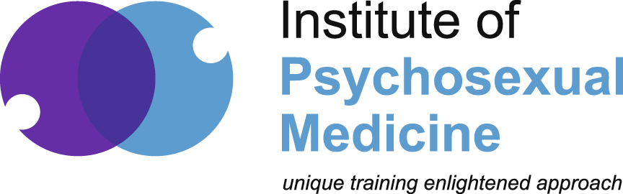 |  | Institute of Psychosexual Medicine  Building 3, Chiswick Park  566 Chiswick High Road  Chiswick  London  W4 5YA  Tel: 020 7580 0631  Office hours Tues and Thurs 9-5  Email: admin@ipm.org.uk  www.ipm.org.uk  Charity No. 298172

Study Day in Psychosexual Medicine and Nursing
An Introductory Course

Date: Saturday 13th September 2014 (application deadline 15th August 2014)

Venue: Derriford Hospital Post Graduate Medical Centre, Plymouth PL6 8DH

Forename: |  | Surname:
Full address, including postcode:
Telephone:
Email:

Fee: |  | Tick professional category
Registered Medical Practitioner - | £150
Nurse - | £100
Physiotherapist - | £100
Other Allied Health Professional - | £100
Note: must satisfying registration requirements

Dietary requirements: | Yes/No If yes, please specify:-
Parking required? | Yes/No. (Exit tokens provided at registration)
Attendance Certificate required: | Yes/No If yes, this will be emailed to address provided.

Payment: | On receipt of application the IPM will send an invoice via email address with payment details. Preferred payment method – Internet Banking. A receipt of payment will also be sent via email.
Deadlines: | Application deadline 15th August 2014. Payment deadline 1st September 2014.
Cancellations: | Cancellations after 1st September will only be refunded if the place can be filled.
Please send this form to the Administrative Secretary by email: admin@ipm.org.uk

